Nama : Diva Almar’atus Sholihah

NRP : 5002211021

Kelas : PLM A

1. Give some examples of when you would need to use a counted loop in MATLAB, and when you would not.

Answer :

Step 1 :

Counted loop in MATLAB is required when :

1. Iteration number in a loop to be notified to the user.
2. varying a plot utilizing the subplot command.

Counted loop is not required to perform any kind of mathematical or logical operation in an array or vector. Counted loop is not required to perform addition or division or logical and operation etc. On an array or vector.

Step 2 :

Hence, an example of where counted loop is required is to notify iterations number to the user. Similarly, an example where counted loop is not required is performing any operation on an array or vector.

1. The Wind Chill Factor (WCF) measures how cold it feels with a given air temperature T (in degrees Fahrenheit) and wind speed V (in miles per hour). One formula for WCF is

WCF = 35.7 + 0.6 T - 35.7 $(V^{0.16})$ + 0.43 $(V^{0.16})$

Write a function to receive the temperature and wind speed as input arguments and return the WCF. Using loops, print a table showing wind chill factors for temperatures ranging from -20 to 55 in steps of 5, and wind speeds ranging from 0 to 55 in steps of 5. Call the function to calculate each wind chill factor.

Answer :

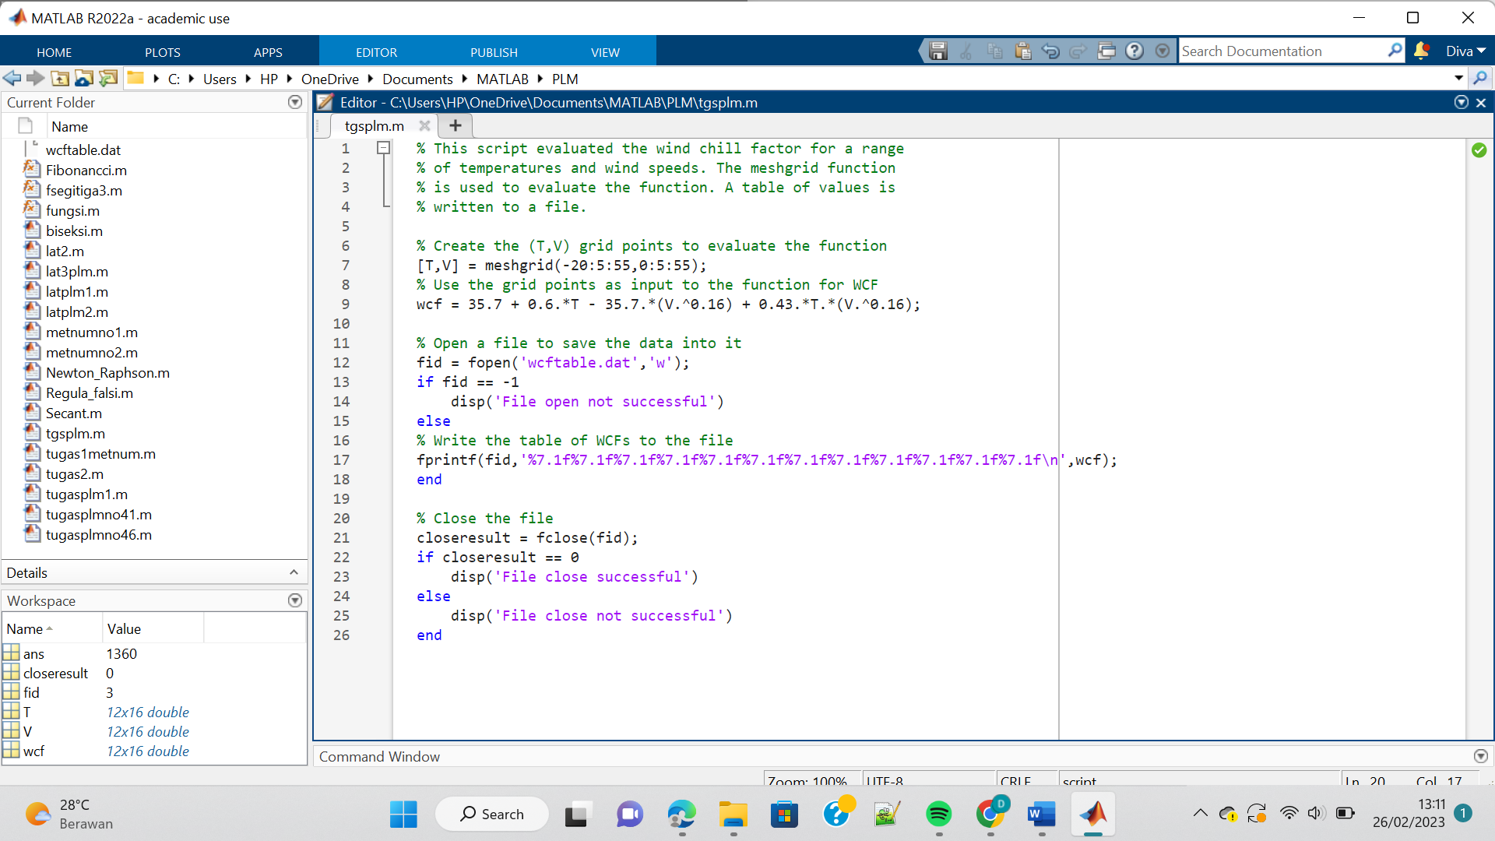

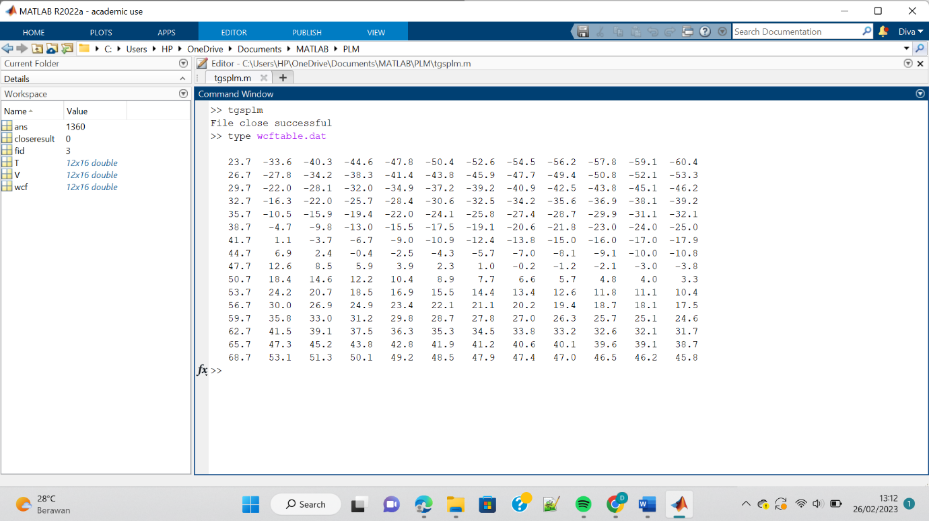

1. Write your own code to perform matrix multiplication. Recall that to multiply two matrices, the inner dimensions must be the same

$${\left[A\right]}_{mxn}{\left[B\right]}_{nxp}={\left[C\right]}_{mxp}$$

Every element in the resulting matrix C is obtained by

$$c_{ij}=\sum_{k=1}^{n}{a_{ik}b_{kj}}$$

So, three nested loops are required.

Answer :

